If you have Microsft SQL Server installed on your system, follow these steps to restore your SQL database from the backup (.bak) file:

Open SSMS and connect to an instance of SQL Server.

Server Name : (localdb)\MSSQLLocalDB

Authentication : windows Authentication

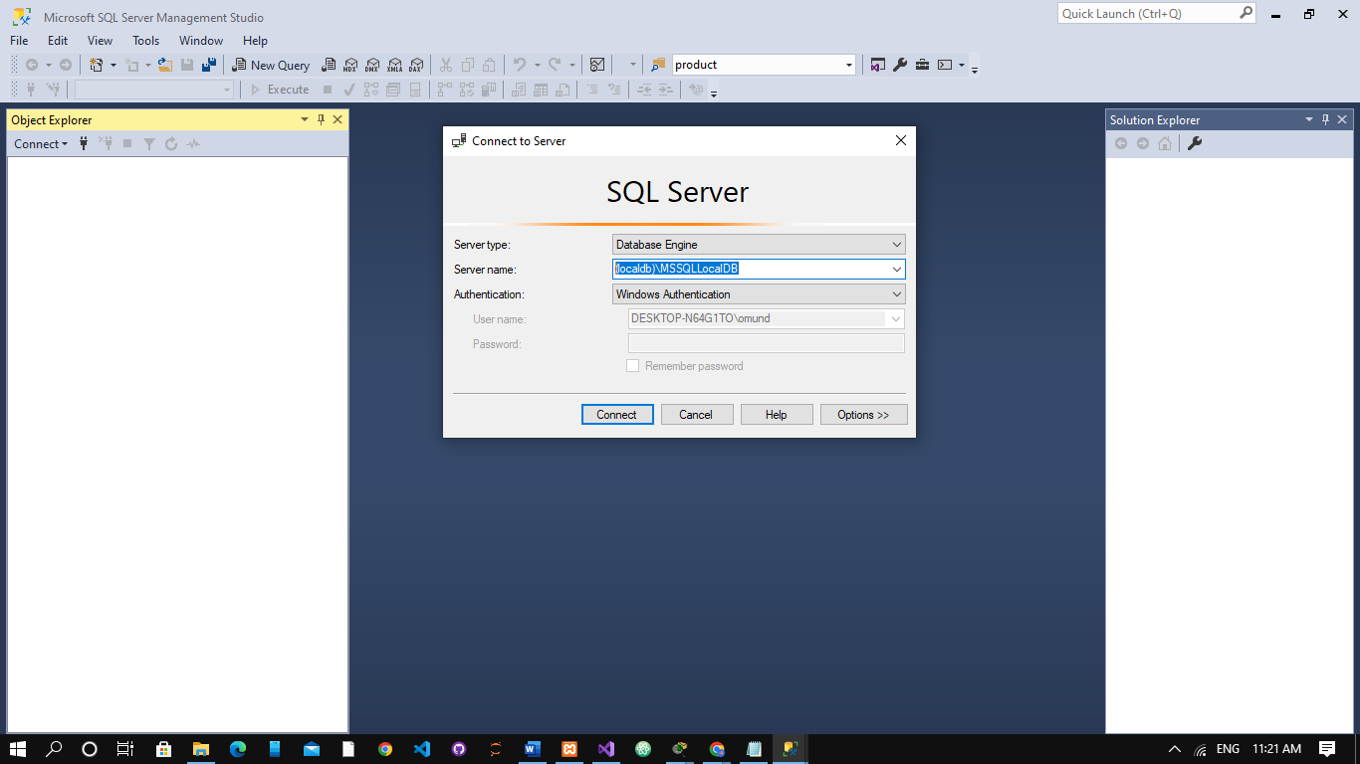

Next, go to Object Explorer and click the Server Name to expand the Server tree. Right-click the Database, and then click Restore Database.



Restore Database Option

Step 5: The Restore Database window is displayed. From the General page, under Source section, select any of these options:

Choose the Device option, and then click the ellipses (...) to find your backup file.

* From ‘Select backup devices’ window, choose File as backup media, and then click Add.
* Locate and select the .BAK file you want to restore, and then click OK.
* Again click OK to return to the Restore Database window.

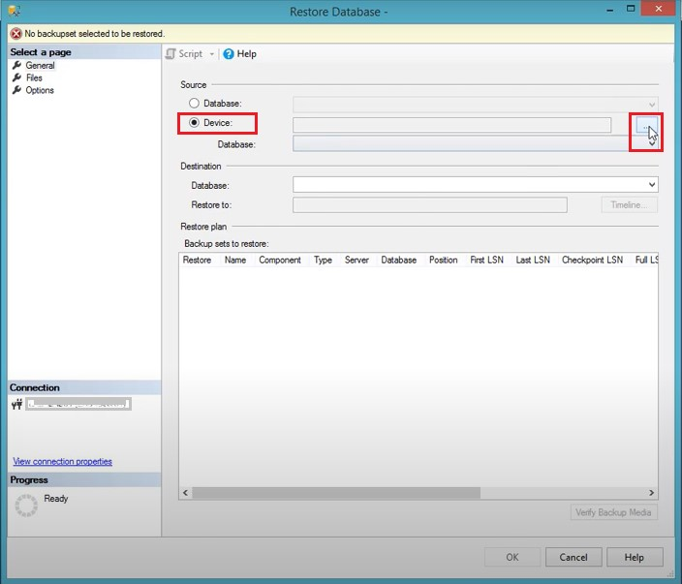

Locate SQL Database Backup File

From ‘Select backup devices’ window, choose File as backup media, and then click Add.

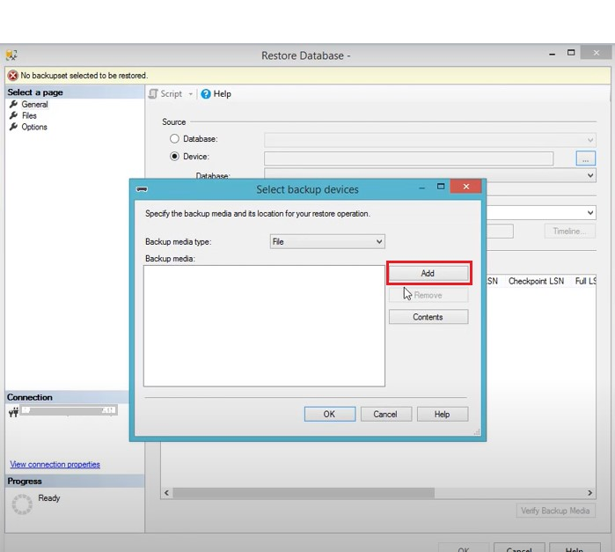

Select Add to Navigate to .BAK File

Locate and select the .BAK file you want to restore, and then click OK.

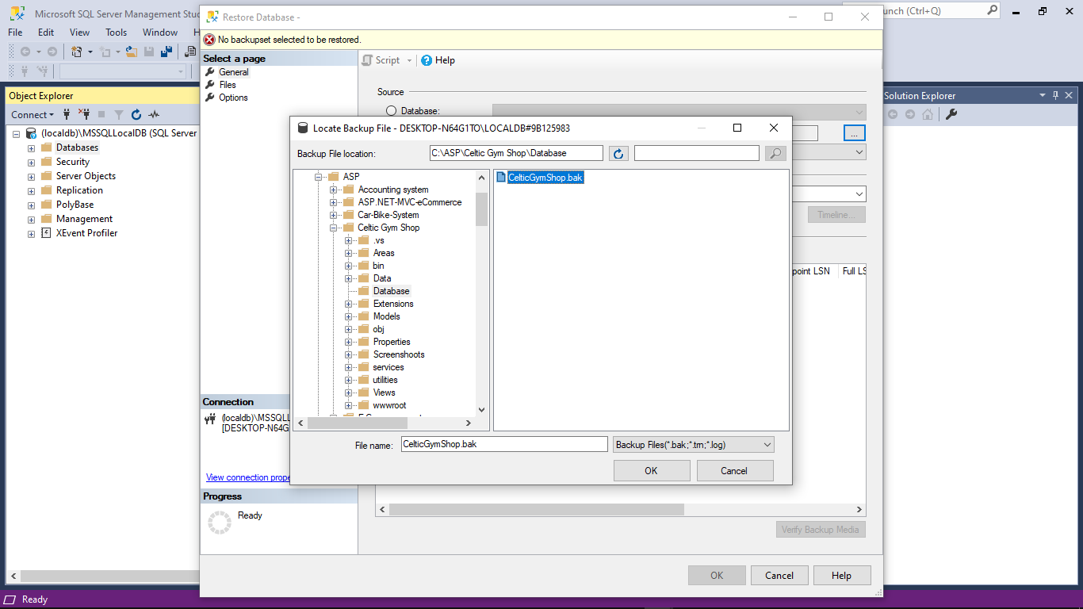

Select the Backup File

Again click OK to return to the 'Restore Database' window.

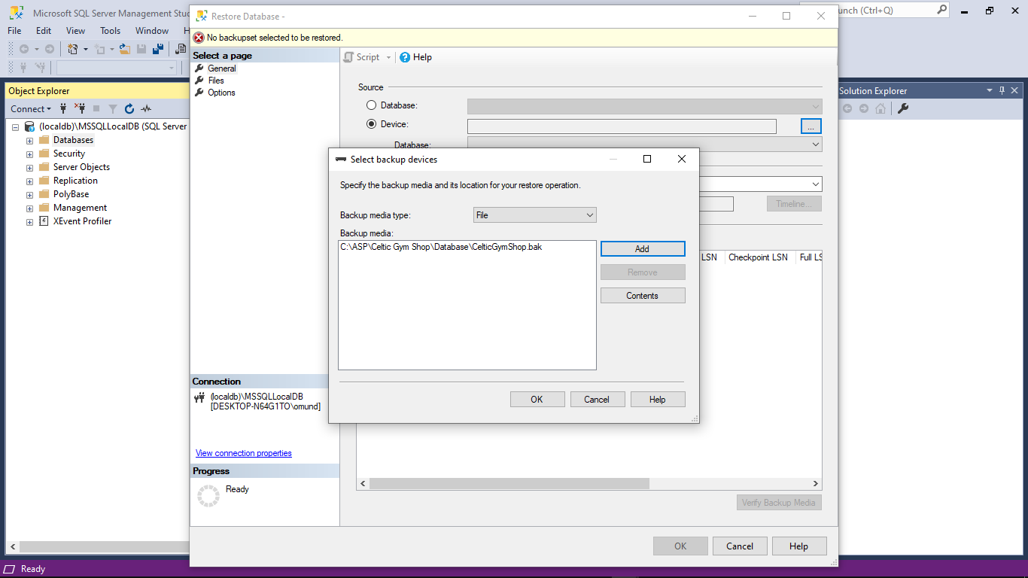

Selected Backup File in Specify Backup Window

The name of the database to be restored is displayed in the Database box under Destination section. And, information of the selected backup file will be added in the Backup sets to restore section.

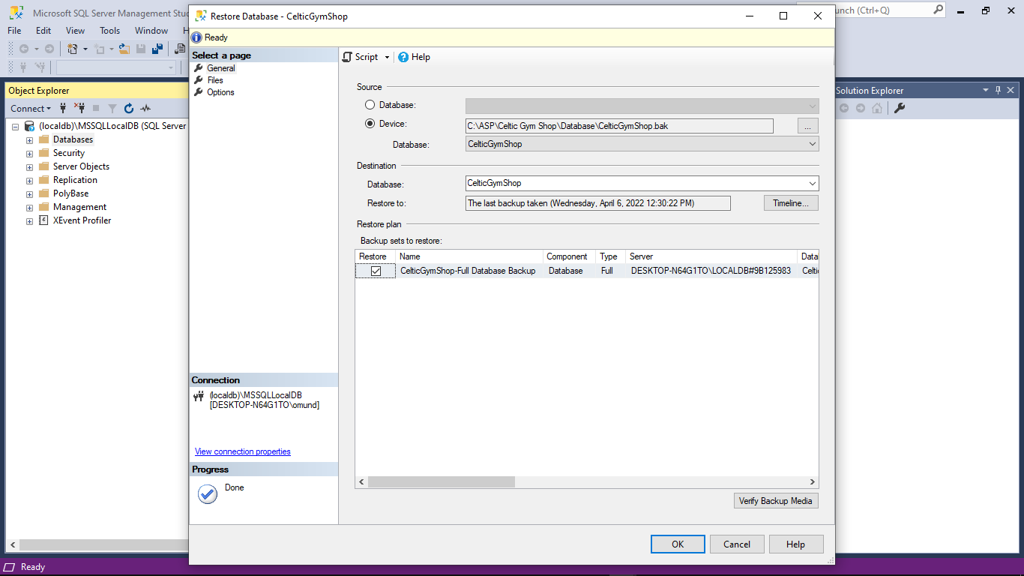

Backup File in Restore Database Window

All the information needed to restore the database from backup file has been entered. You just need to click on the OK button to restore the database.

The window with restore progress is displayed.



Click OK when the ‘restore of database completed successfully’ message pops up.

